ServletContext is an interface and is part of javax.servlet.ServletContext package.

Servlet Container implements this ServletContext interface.

As soon as we deploy our web application, even before any client request comes in, Servlet container creates ServletContext.

There will be only one ServletContext for entire web application. Container will destroy this object when we undeploy our application from the container.

The data that we put into Servlet Context object in our application is accessible through out the applicaiton.

During Servlet initialization, container injects the context object into Servlet.

How to retrieve ServletContext ??

- init method with config

public void init(ServletConfig config) {

ServletContext context = config.getServletContext();
String driver = context.getInitParameter("driver");
}

- init method without config

public void init( ) {

ServletContext context = getServletContext();
String driver = context.getInitParameter("driver");
}

- accessing ServletContext in service method

public void service( .... ) {

ServletContext context = getServletContext();

}

ServletContext object is an application level object. The data contained in ServletContext object is shared across servlets. ServletContext object is created by container and injected into servlets during initialization.

4 uses of ServletContext object:

- Share and manipulate data at application level.
We can set data in one servlet and access it in another servlet.
setAttribute( )
getAttribute( )
removeAttribute( )
getAttributeNames( )

- To deal with context params or application level parameters
- To create the RequestDispatcher object for inter-servlet communication.
- To store information into the server log files using the log( ) method.

What are Context parameters ??

These are like init-params, name-value pairs of texual information that are supplied through the web.xml for our web application.

Context params can be accessed by any servlet or JSP pages in our web application.

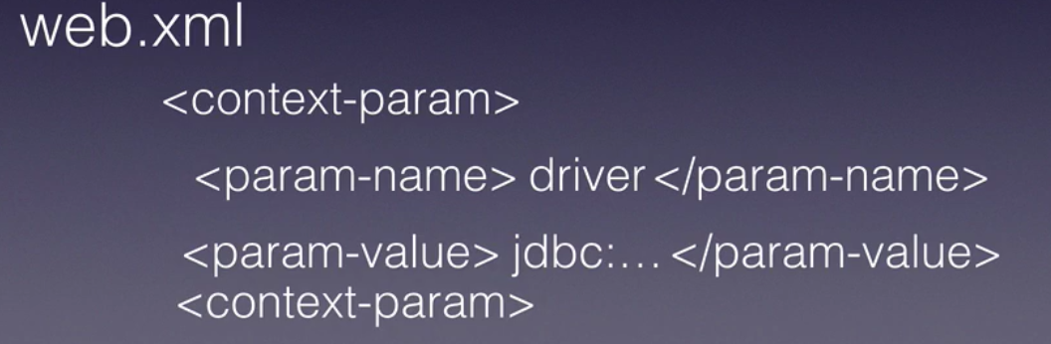
Container reads the web.xml for all context params and creates ServletContext object.

ServletContext context = getServletContext();
String driver = context.getInitParameter("driver");

Example :

Configuring context params in web.xml file :

<context-param>
<param-name>dbConnectionString</param-name>
<param-value>jdbc:mysql://localhost/mylocaldb</param-value>
</context-param>
<context-param>
<param-name>dbUserName</param-name>
<param-value>root</param-value>
</context-param>
<context-param>
<param-name>dbPassWord</param-name>
<param-value>chotu123</param-value>
</context-param>

Accessing the context params in Servlet :

// this gets called ONLY ONCE
public void init(ServletConfig config) {
try {
ServletContext context = config.getServletContext();
Class.forName("com.mysql.jdbc.Driver");
connection = DriverManager.getConnection(
context.getInitParameter("dbConnectionString"),
context.getInitParameter("dbUserName"), context.getInitParameter("dbPassWord"));
} catch (SQLException e) {
e.printStackTrace();
} catch (ClassNotFoundException e) {
e.printStackTrace();
}
}

Display all context params :

Enumeration<String> parameterNames = context.getInitParameterNames();

while(parameterNames.hasMoreElements()){
String eachName = parameterNames.nextElement();
System.out.println("Context param name : " + eachName);
System.out.println("Context param value : " + context.getInitParameter(eachName));
}

